<https://www.youtube.com/watch?v=xuB1Id2Wxak>

<https://github.com/bhupendra-dataarch/Project1.git>

Git Command 🡪 <https://dzone.com/articles/top-20-git-commands-with-examples>

Git init : This command is used to start a new repository.

Git clone : This command is used to obtain a repository from an existing URL.

Git add : This command adds a file to the staging area.

Usage: git add *

Git commit : This command commits any files you’ve added with the git add command and also commits any files you’ve changed since then.

Git diff : This command shows the differences between the files in the staging area and the latest version present.

Usage: git diff [first branch] [second branch]

This command shows the differences between the two branches mentioned.

Git status : This command lists all the files that have to be committed.

Git rm : This command deletes the file from your working directory and stages the deletion.

Git log : This command is used to list the version history for the current branch.

Git show : This command shows the metadata and content changes of the specified commit.

Git tag : This command is used to give tags to the specified commit.

Git branch : list all the local branch in current Repo .

Usage: git branch [branch name]

Git checkout : switch from one branch to another .

Git merge : This command merges the specified branch’s history into the current branch.

Git remote : This command is used to connect your local repository to the remote server.

Git push : This command sends the committed changes of master branch to your remote repository

Git pull : This command fetches and merges changes on the remote server to your working directory.

Git stash : This command temporarily stores all the modified tracked files.

============

git pull you can fetch from Git Repo to local Repo –

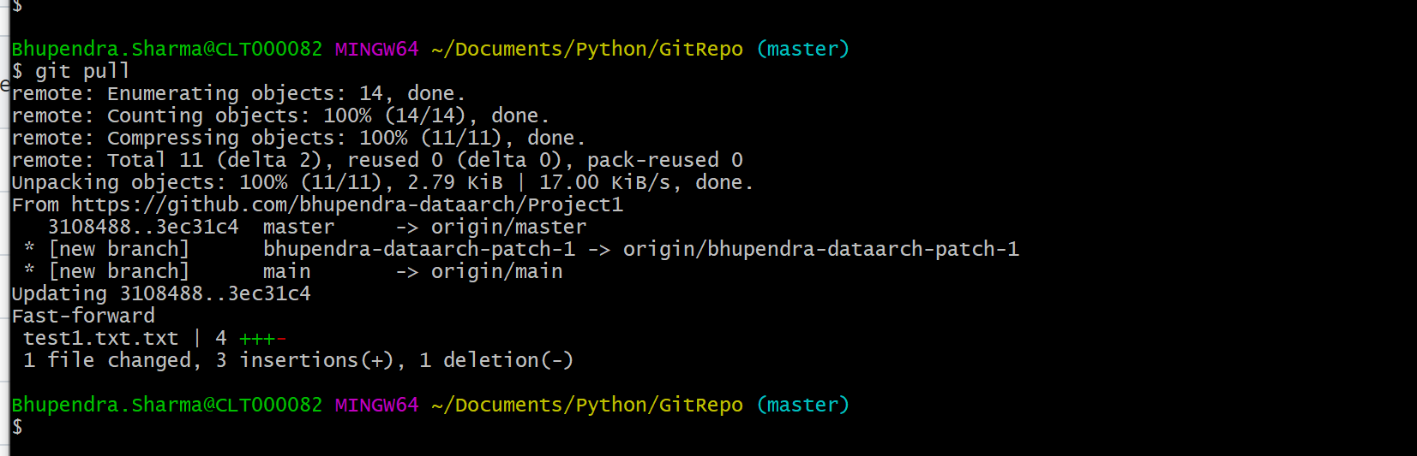

Git push –

Move to Git Repo –

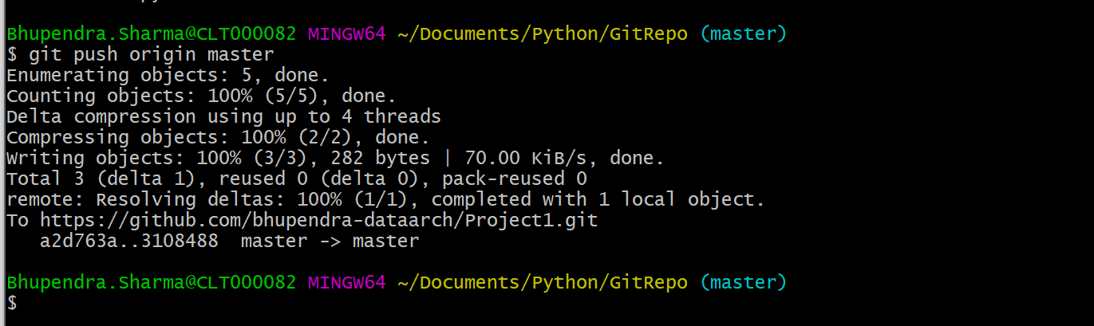

New branch created –

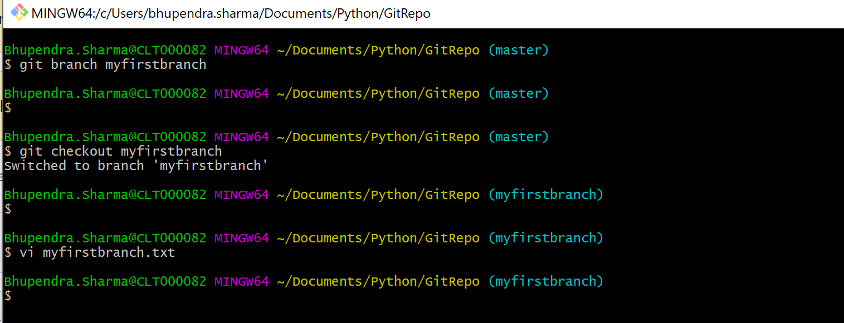

All file coming from master and few new file created in new branch –

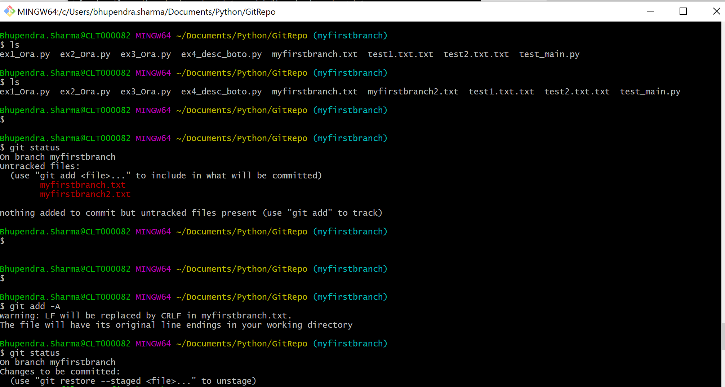

File add and commit –

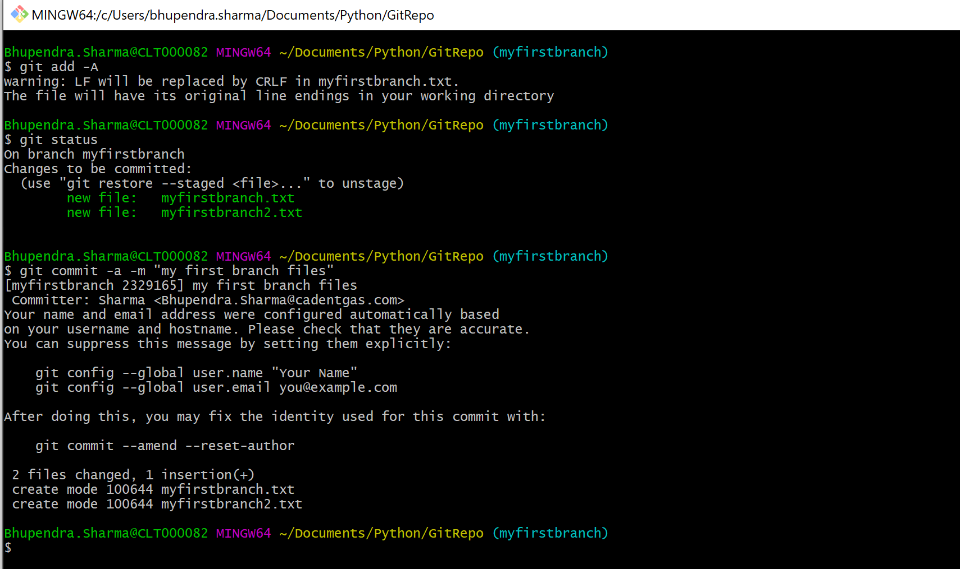

Push to Remote Repo –

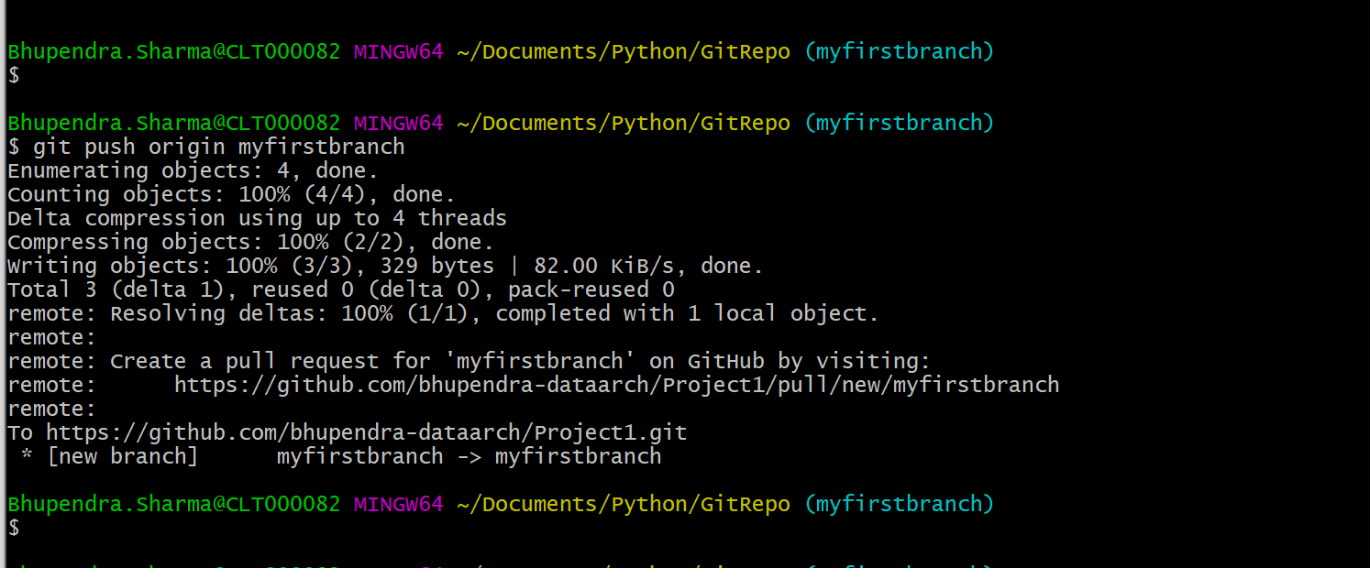

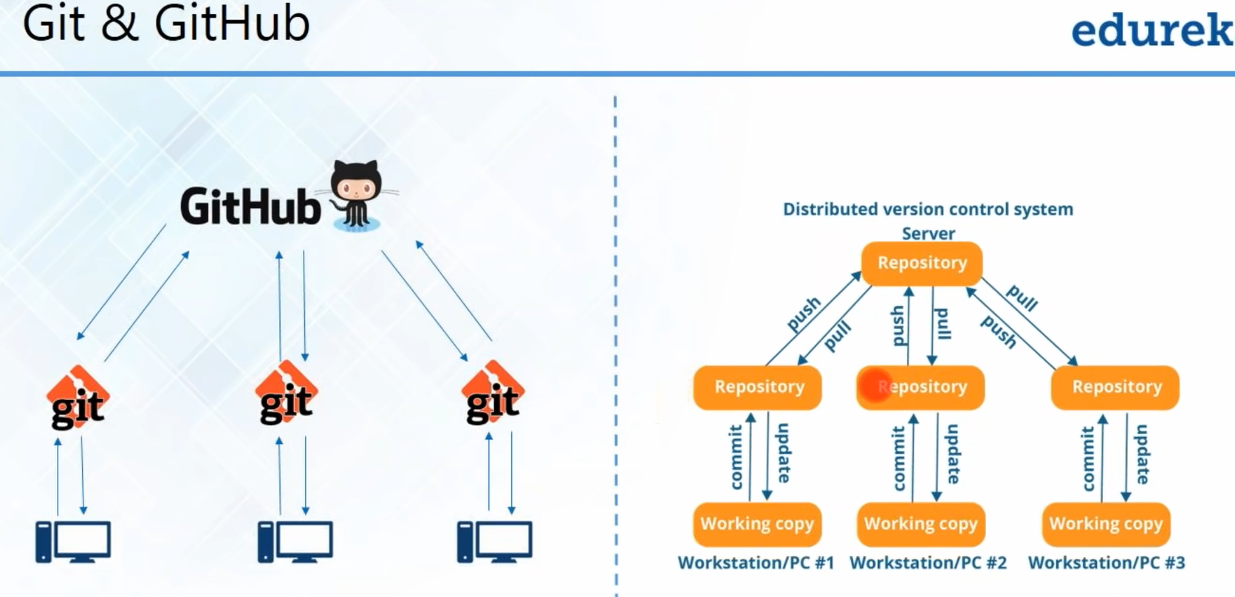

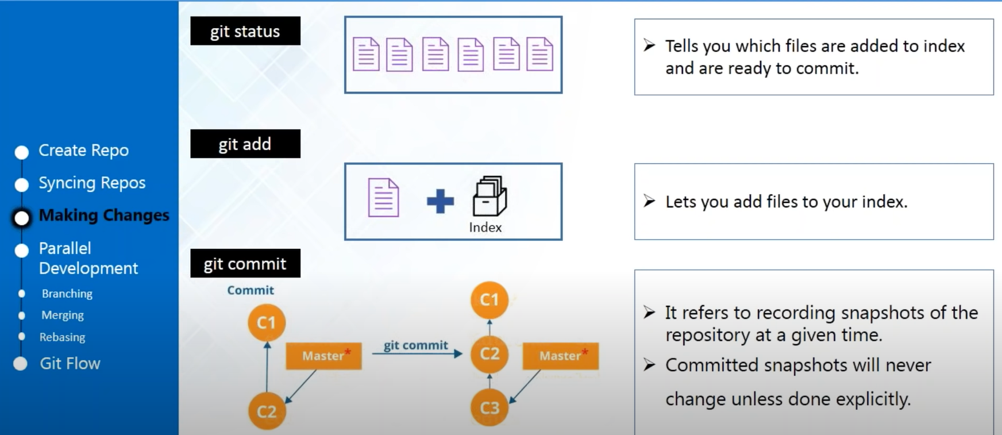

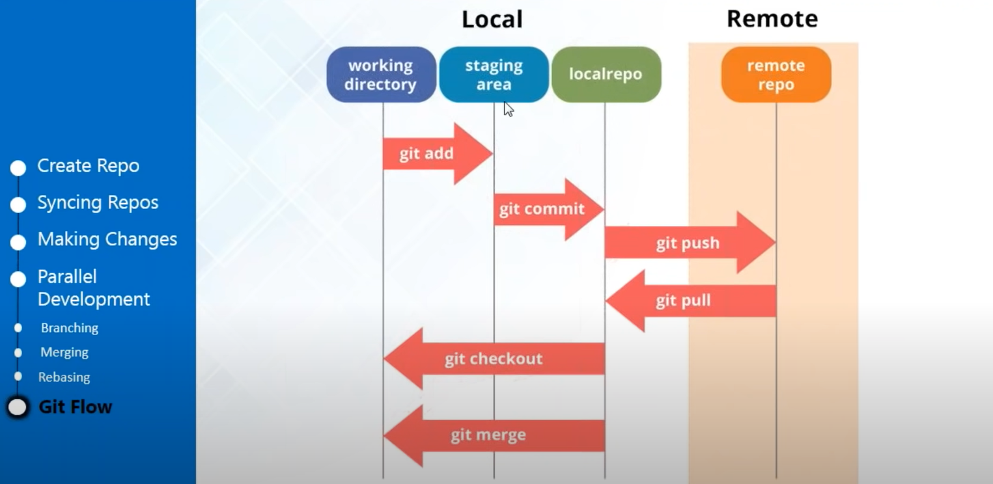

**Git status** - give you the status for local repository . edul.txt still not committed to central Repository in Git.

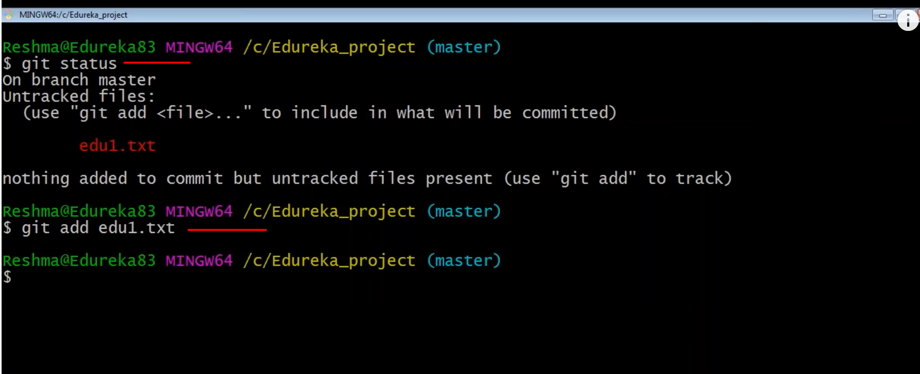

After add edul.txt –

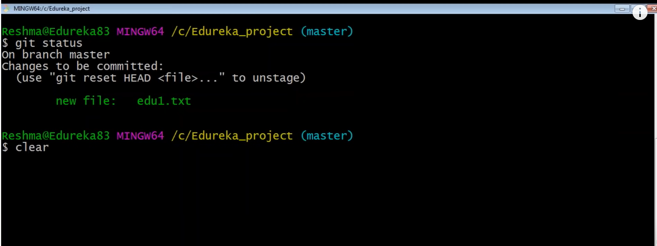

Commit the file in local repository –

-m , message parameter

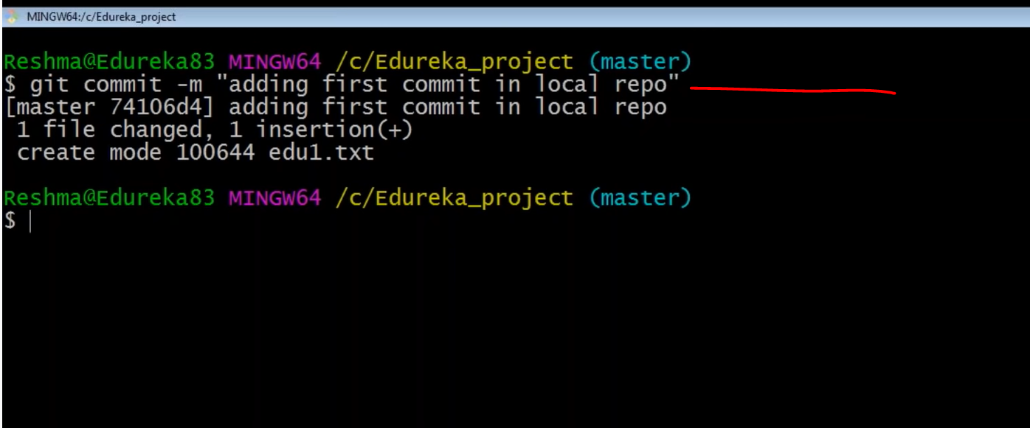

Adding few more file in local Repo but not added in the Index –

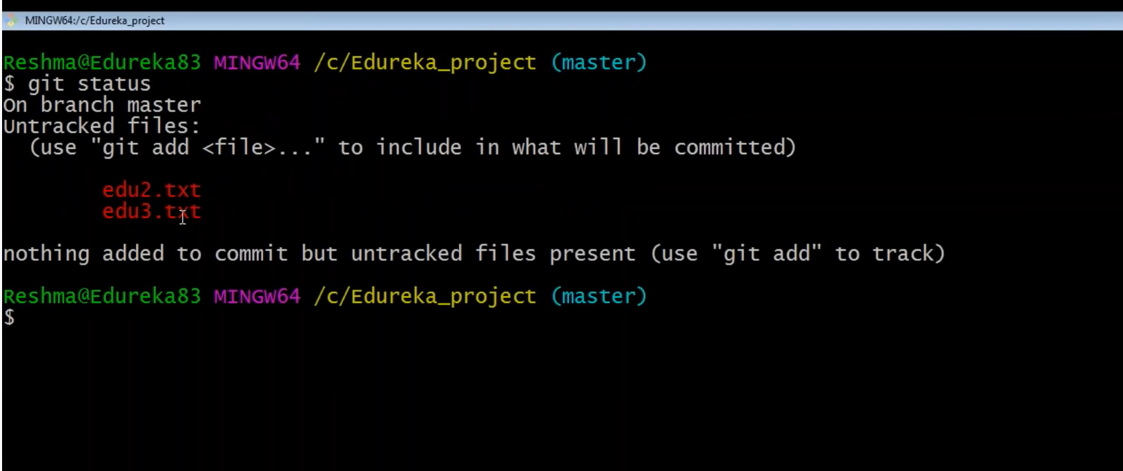

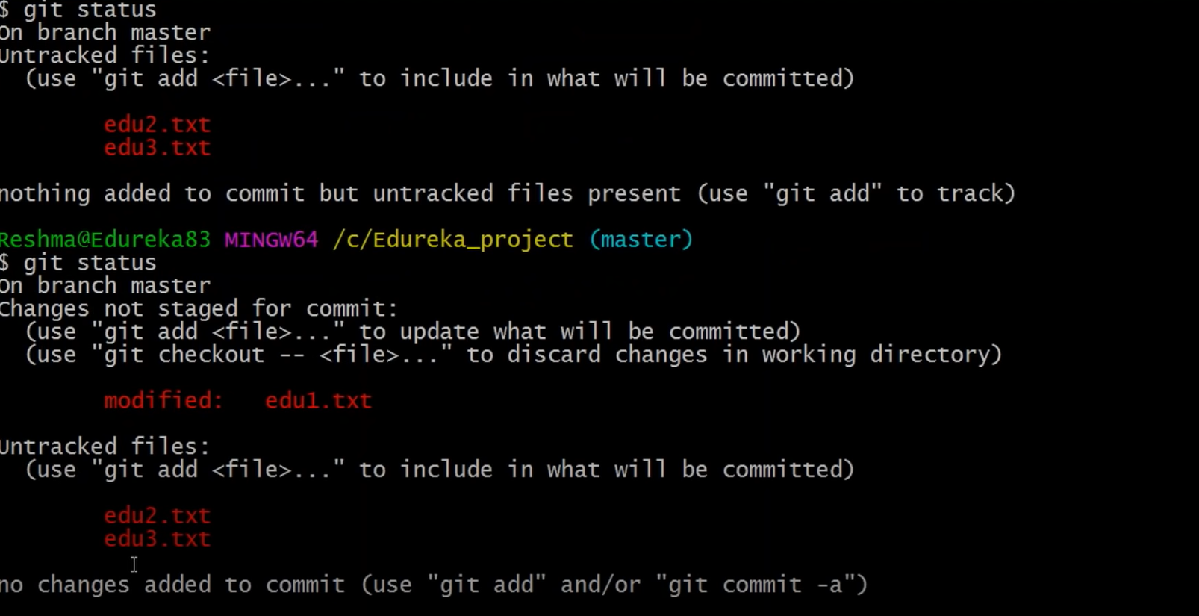

Add multiple in Index .

-A , parameter to add multiple file in Index .

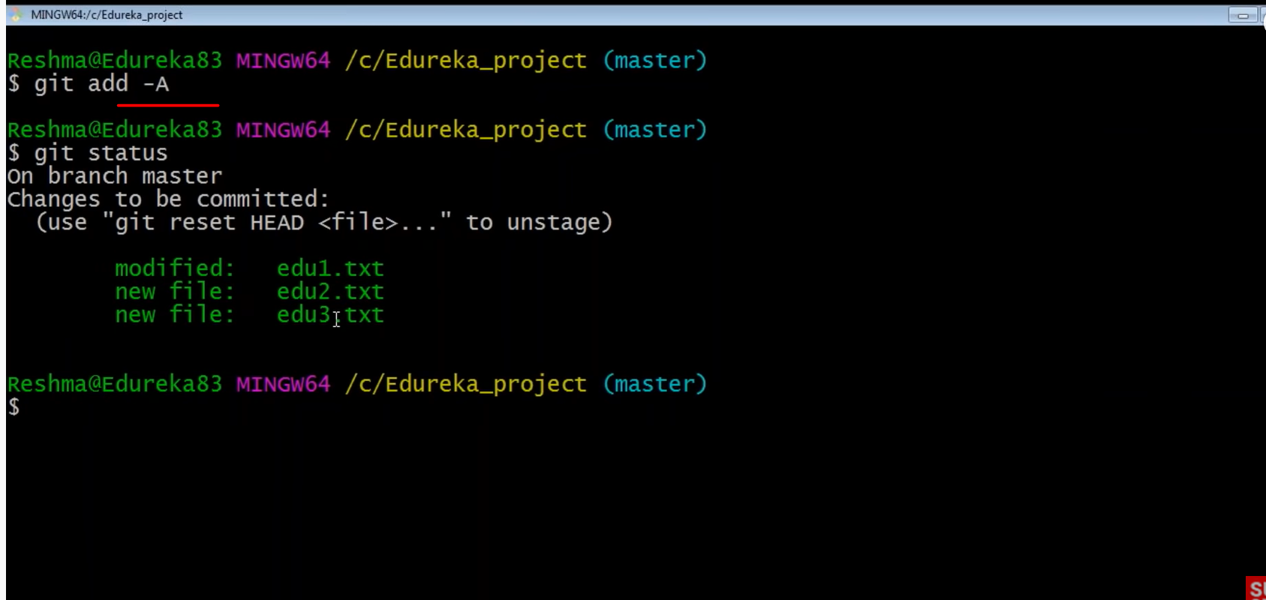

committed few files using commit –

git commit -a

-a , parameter for commit multiple files .

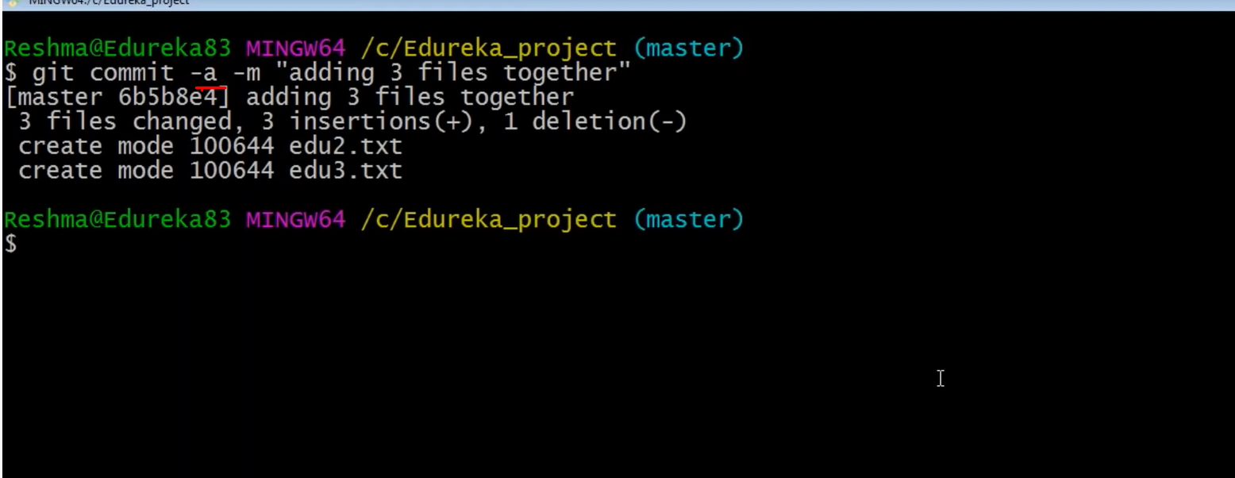

Git log , to check

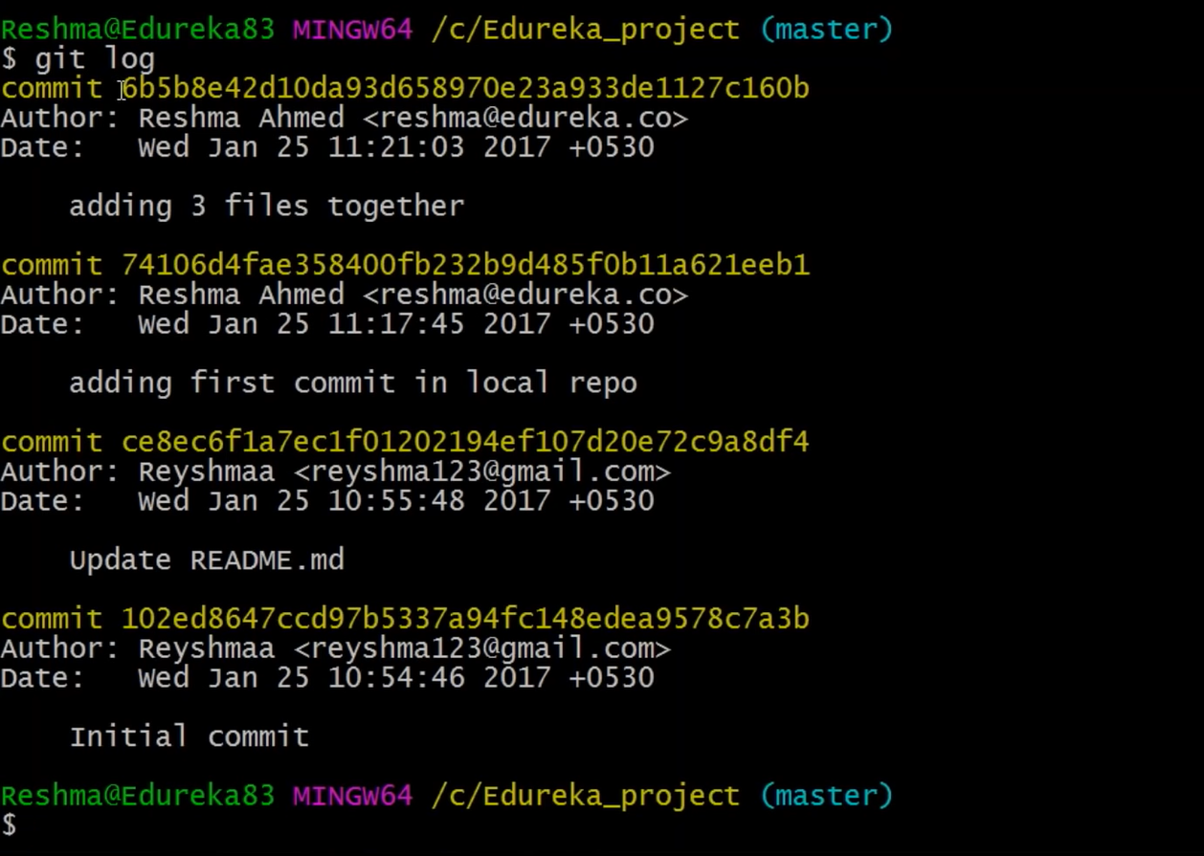

Branching –

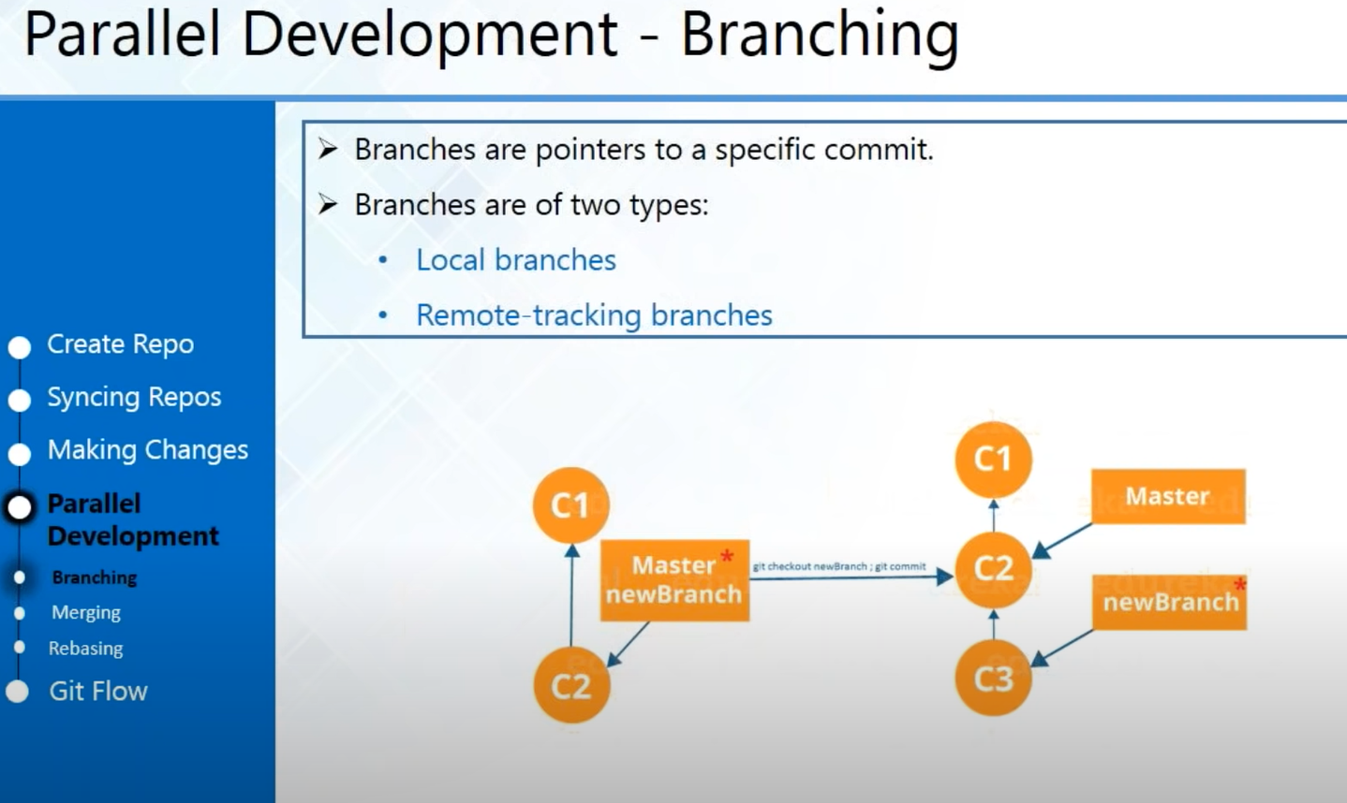

By default create the master branch , you can create new branch –

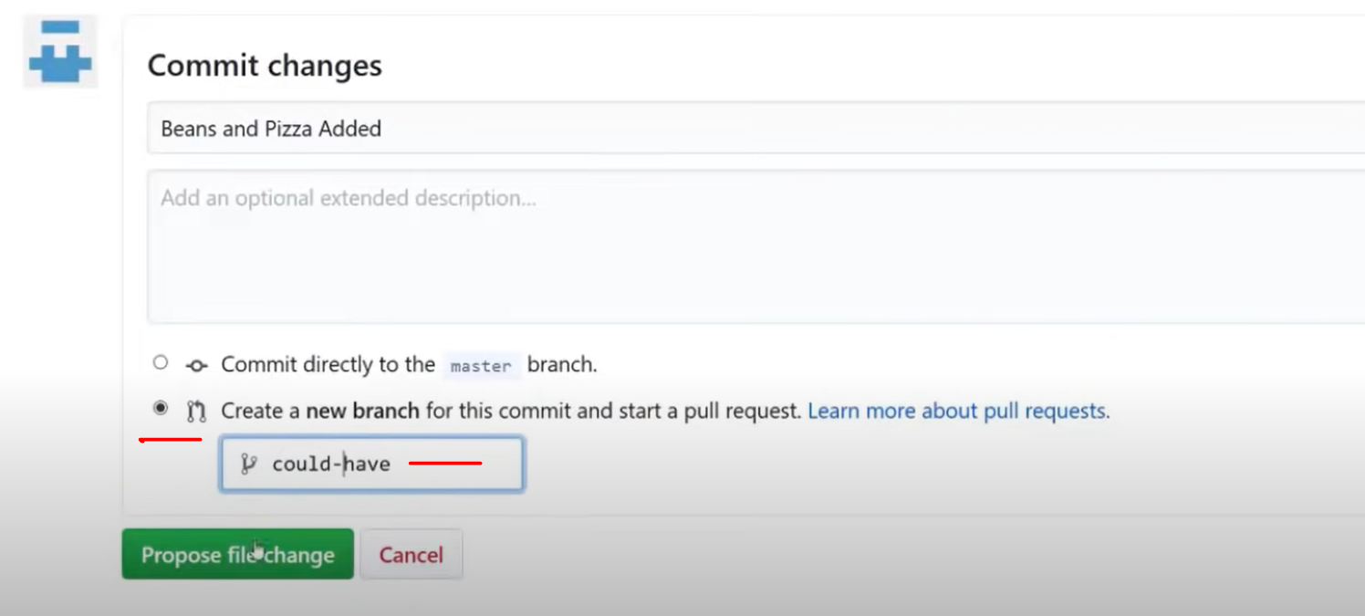

You can murge the two brach by resolving file conflicts .

Command Line , you can create the branch and switch –

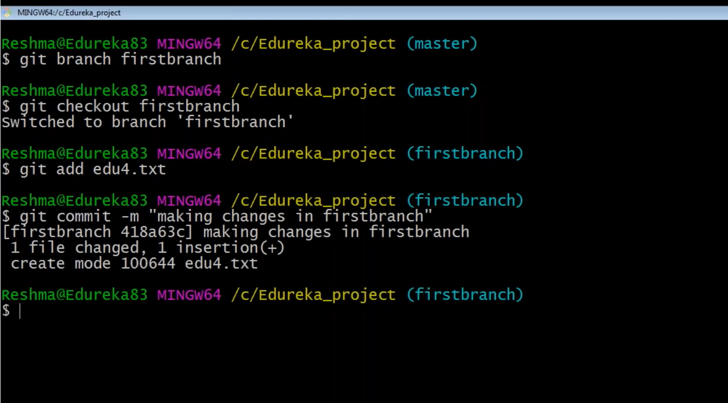

Create new file and add/commit in firstbranch .

All file in your firstbranch and that new file not in your master branch as you created in your firstbranch -

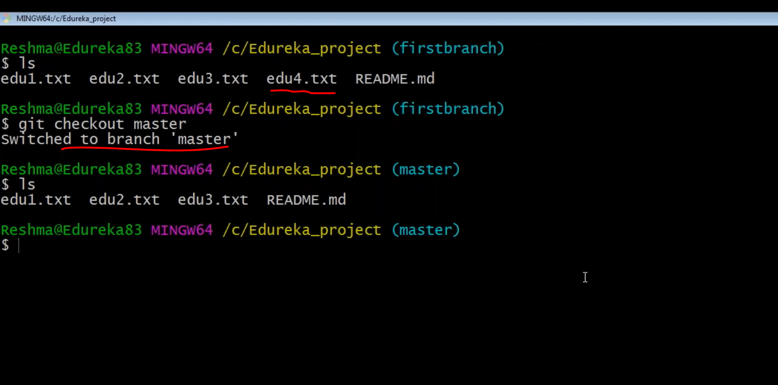

Maraging Branch –

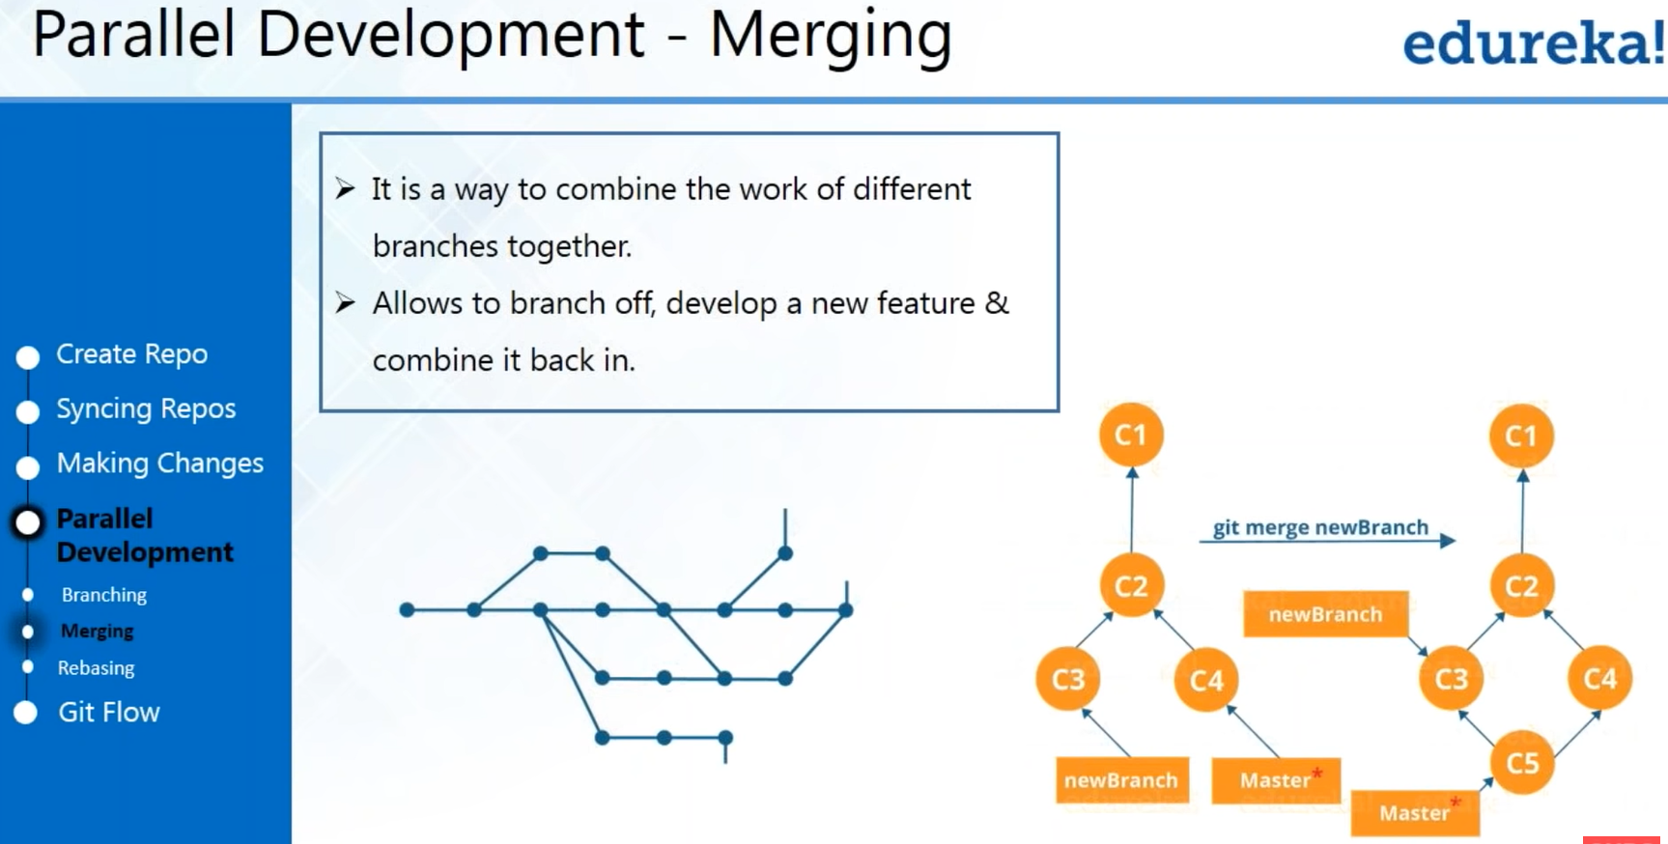

Git merge –

Merge command to merge firstbranch with master and now edu4.txt showing in master branch .

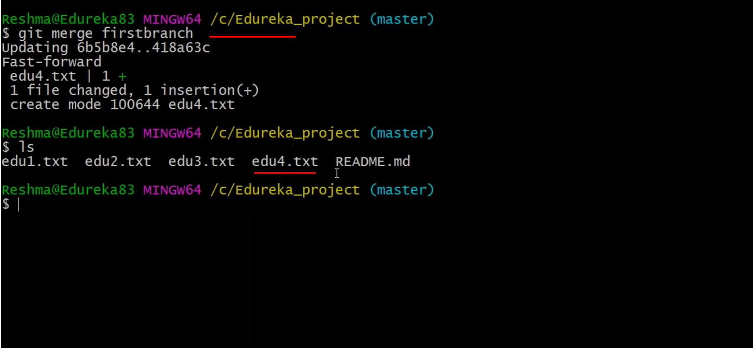

You can modify your file later in firstbranch and just commit , you no need to add file again as file already added -

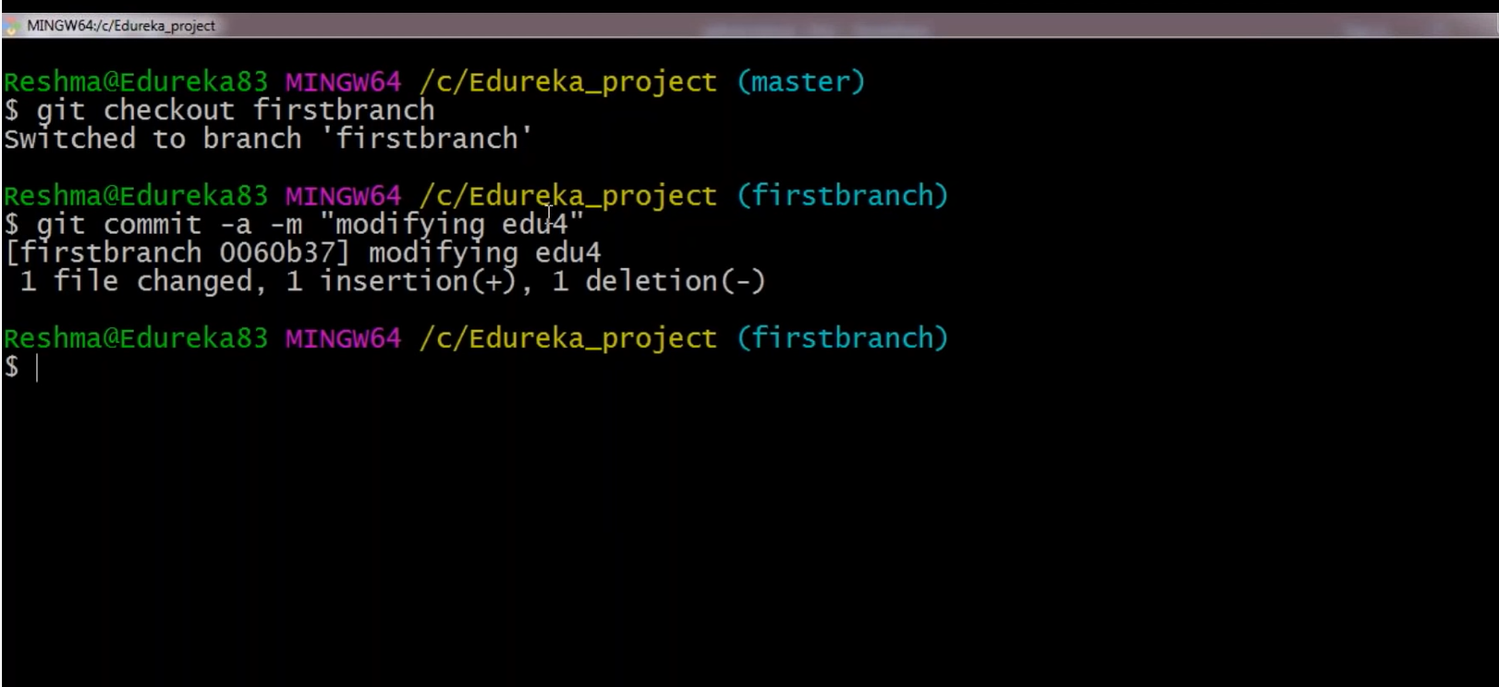

That file modification will not show in master branch –

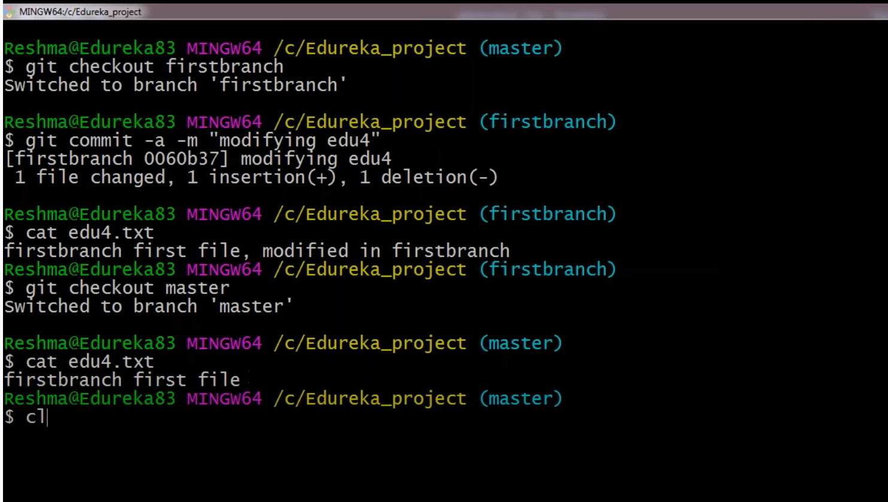

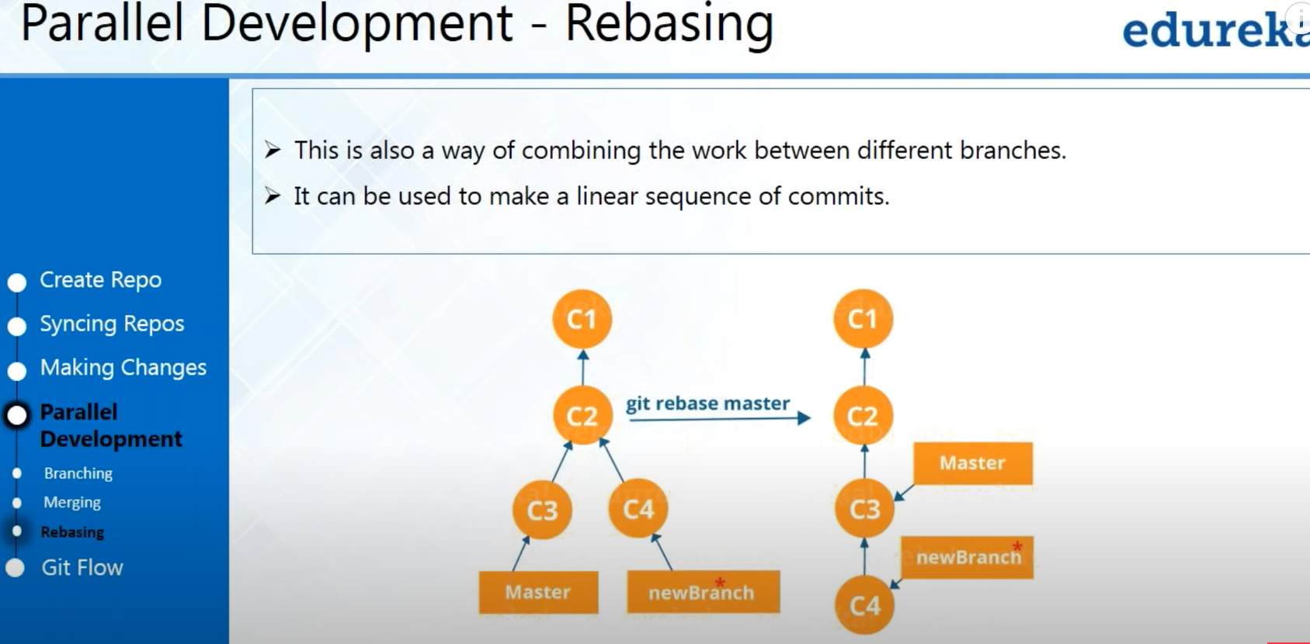

Rebasing similar as merging –

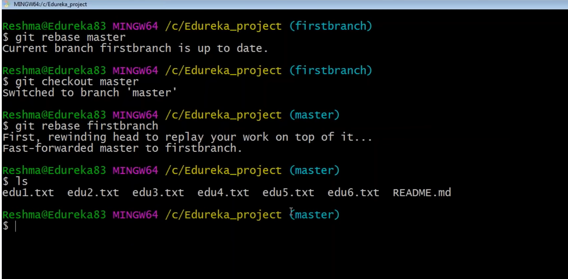

Push Request –

Ssh/https

First create ssh key on local server/laptop and copy key file-

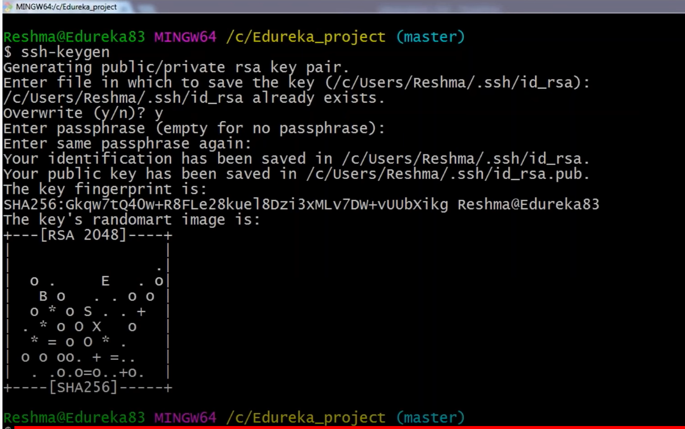

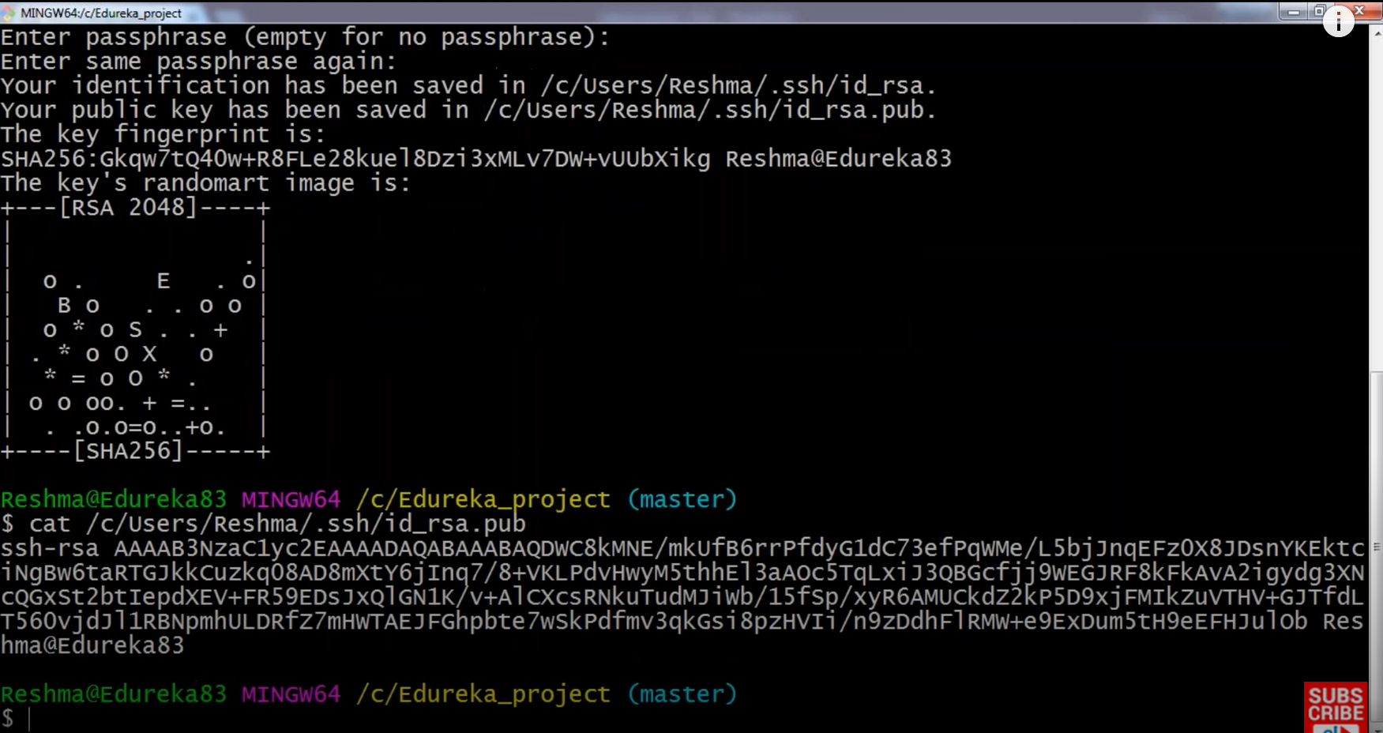

Copy the ssh key in Git setting –

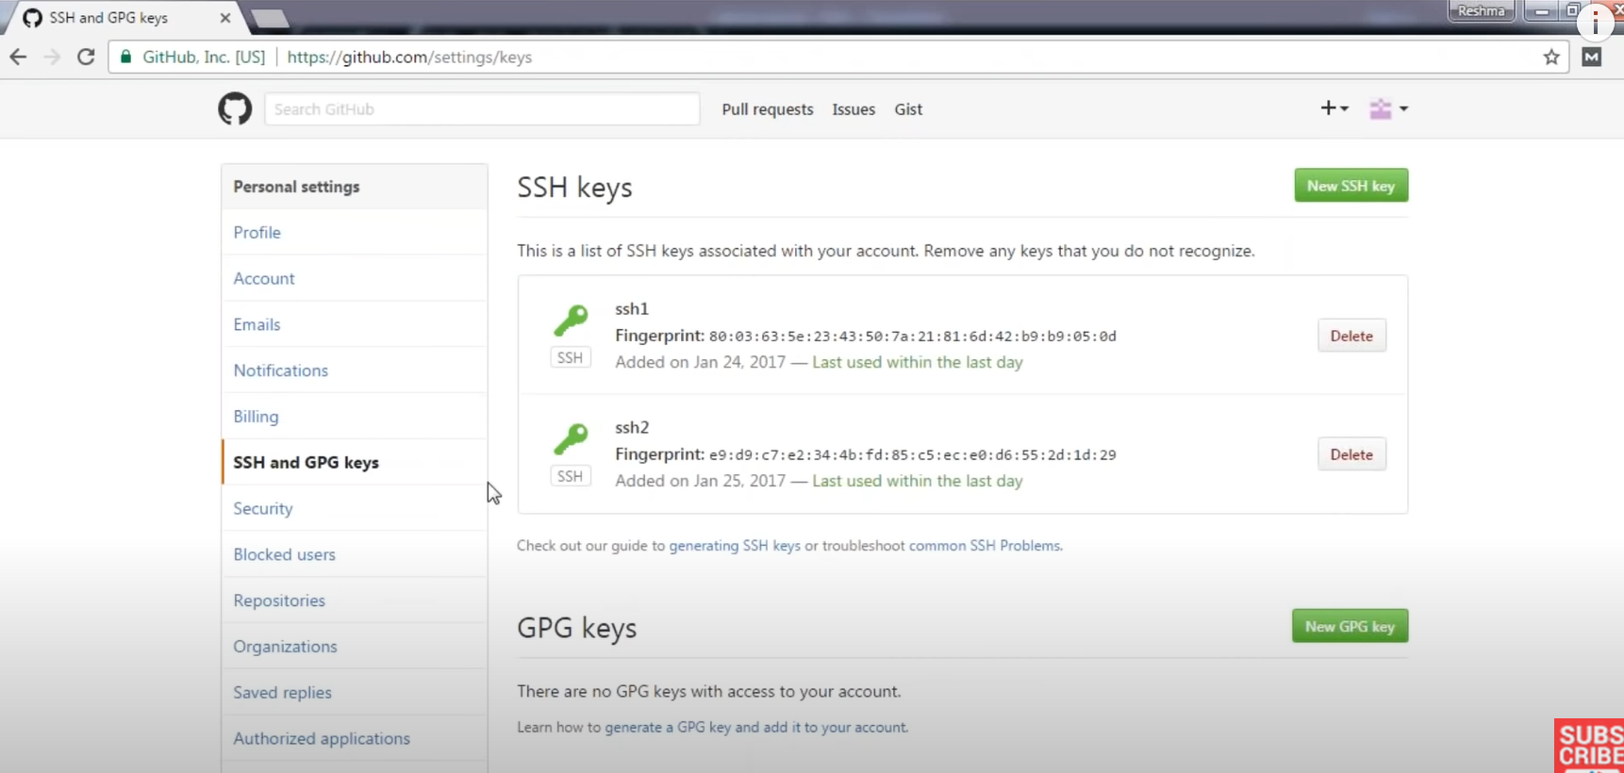

Now authenticate the key –

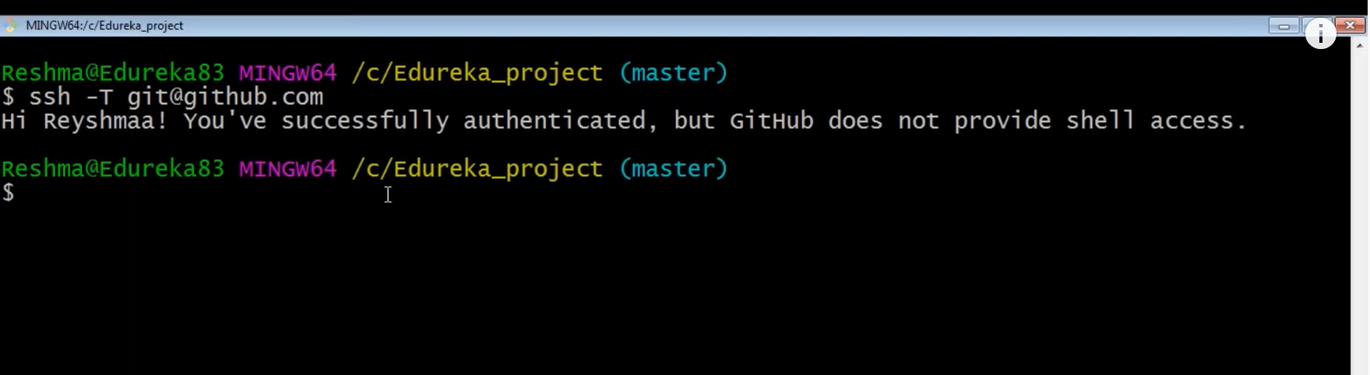

You can create new branch and push all the work to first branch –

Push Origin Firstbranch

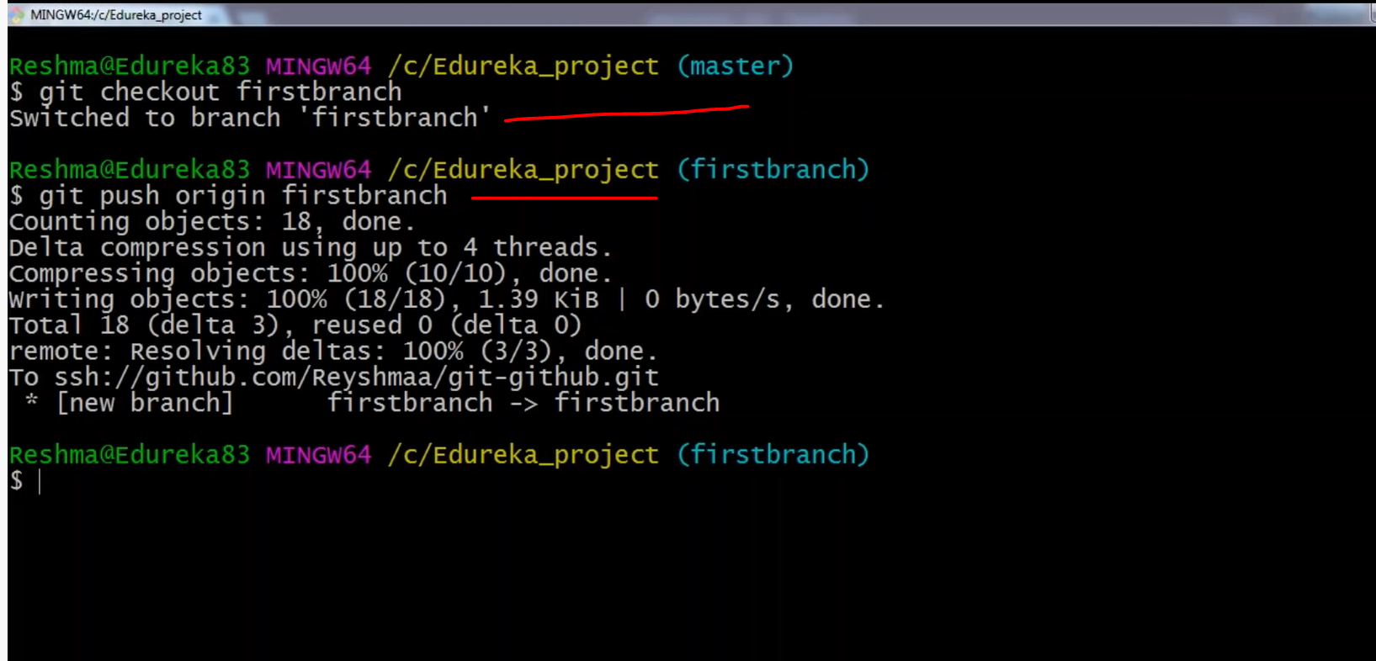

Push Origin master branch

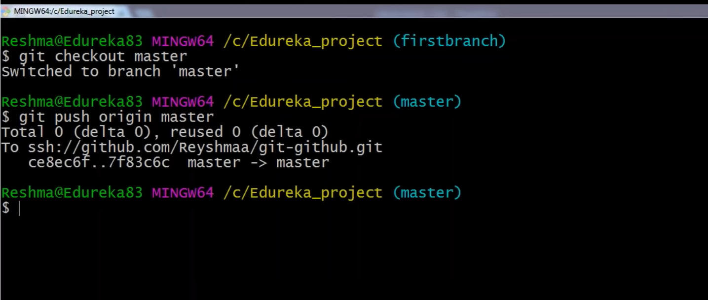

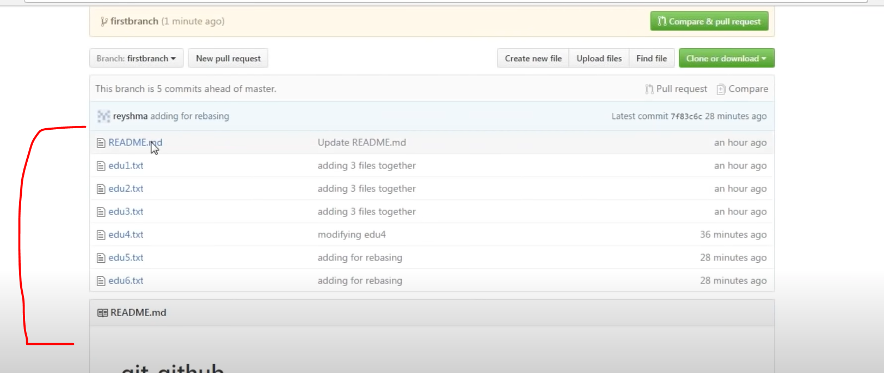

Revert the Change after commit –

Check git log

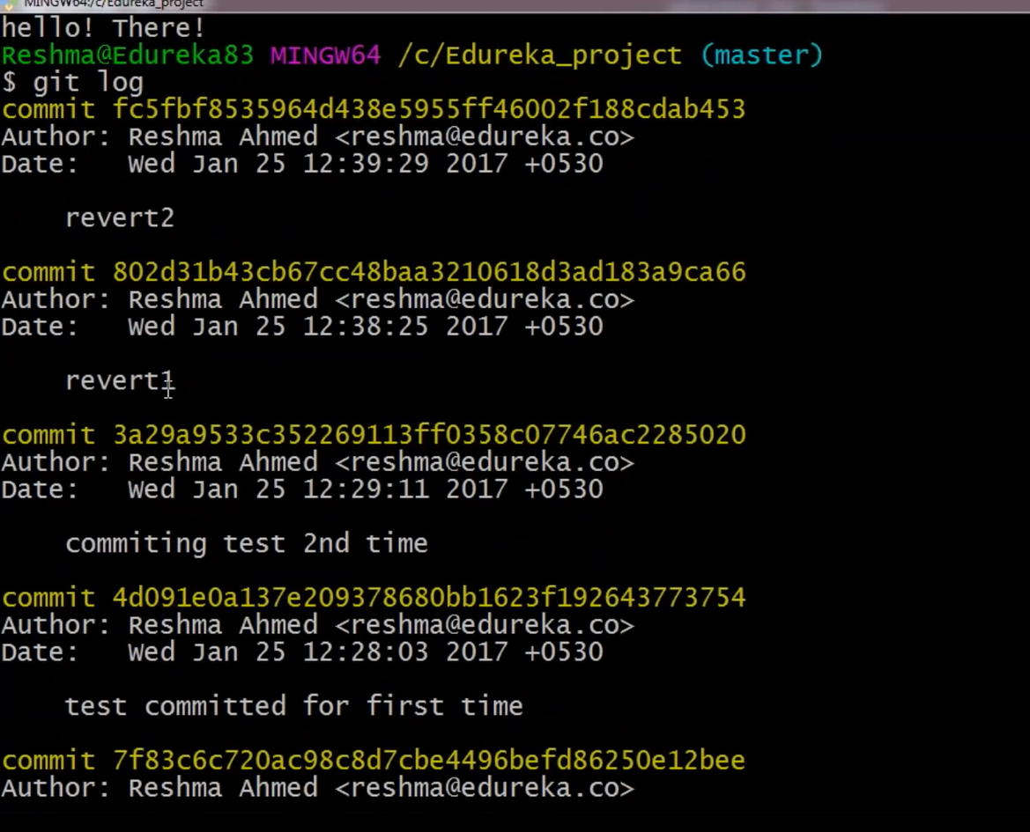

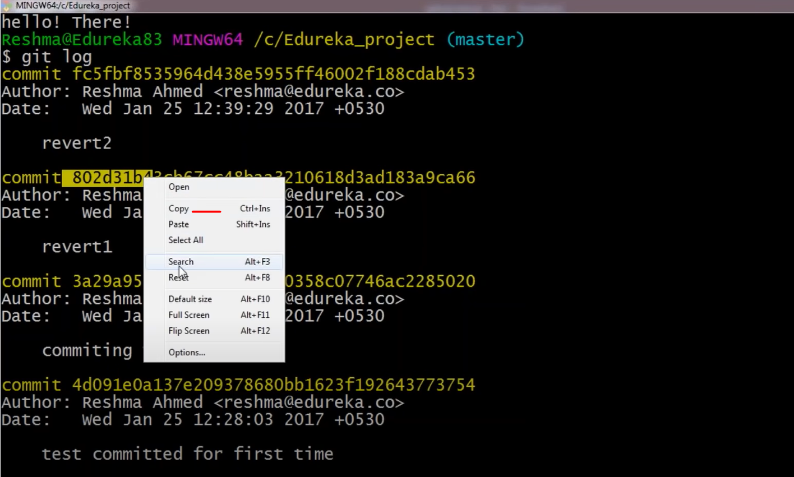

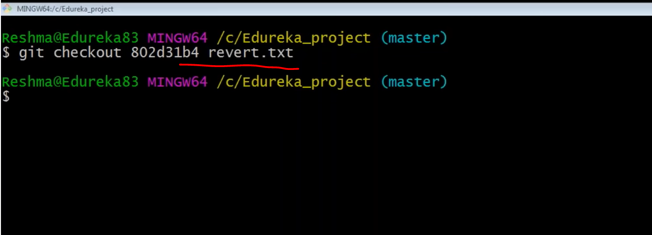

Git Initialize and Status -

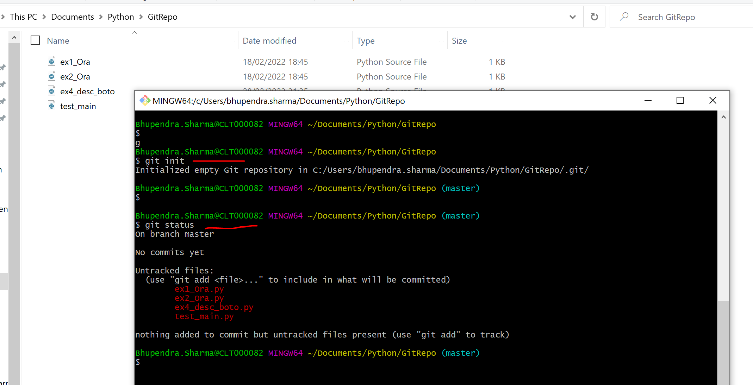

Create ssh key to push and pull file to Github –

Got to account and settings -

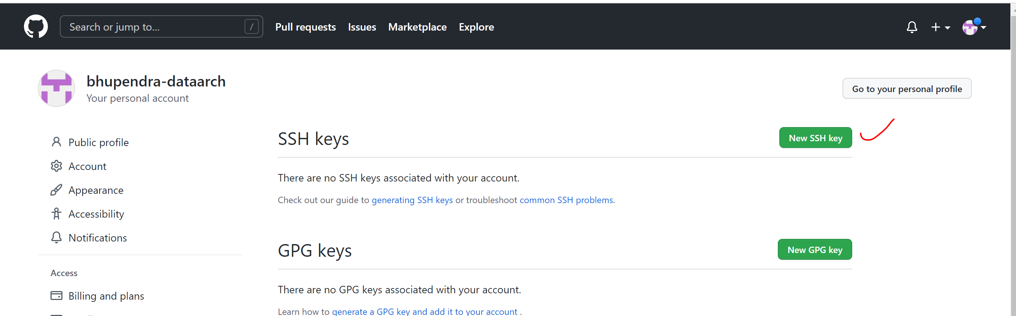

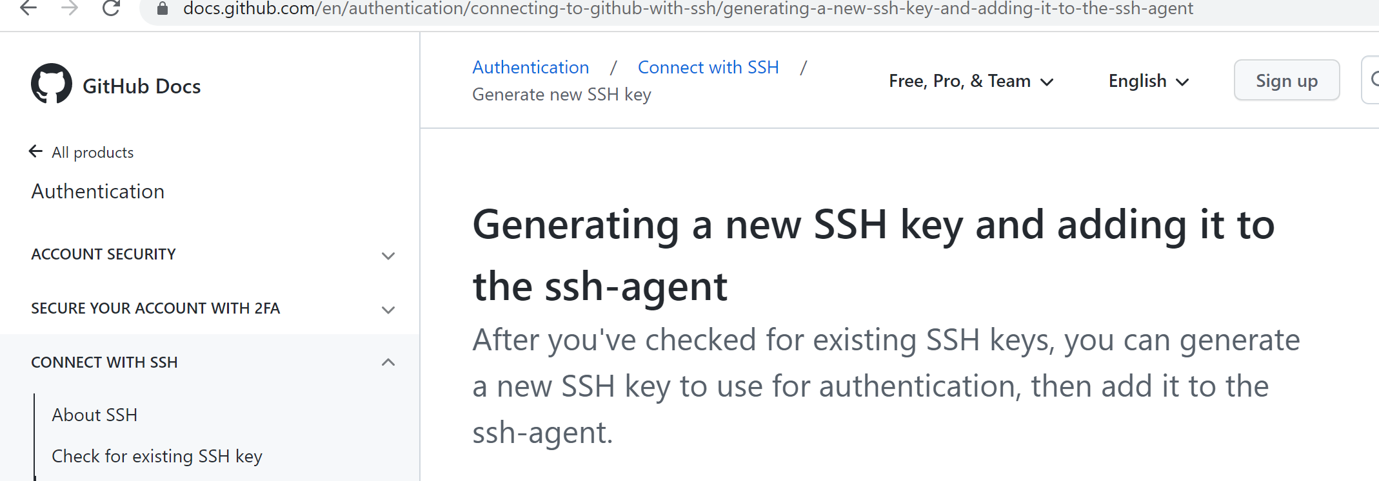

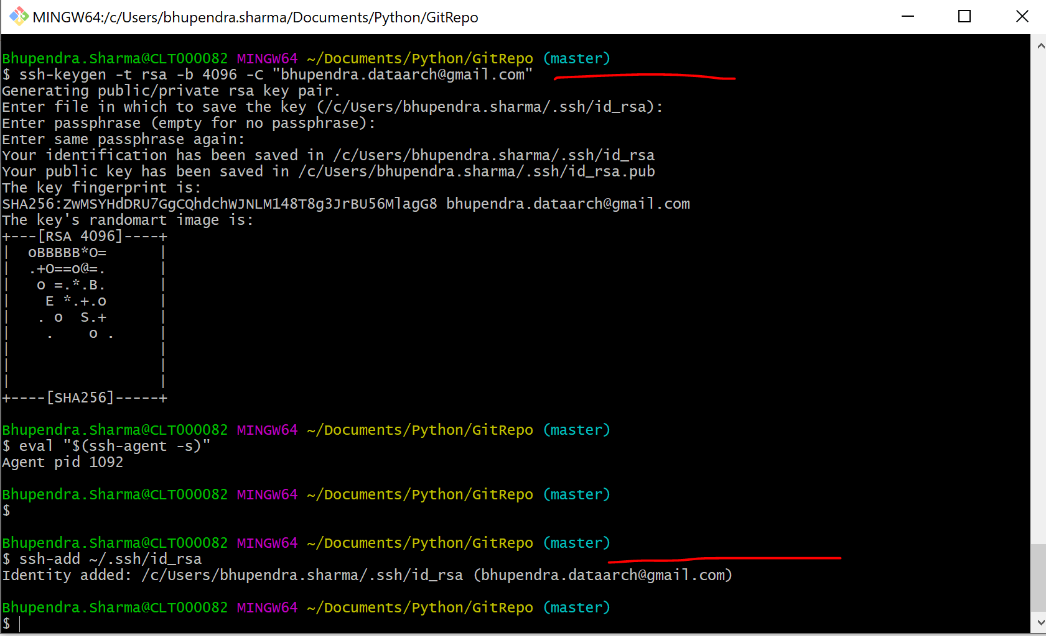

Git Push and Pull Method –